Excel Assignment #8

Ans.1 – Excel includes a handy time-saving feature called AutoComplete. This feature can save you time when you are entering lots of similar information in a column. You may already have noticed this feature before—when you start to type something in a cell, Excel tries to guess what you are typing and shows a "match" that you can accept simply by pressing **Enter**.

The "matches" that Excel uses in its "guess" is nothing but the contents of the cells in the column, above where you are making your entry. For instance, if you have information in cells A1 through A6 and you are entering a value in cell A7, Excel looks at what you are typing. If the first few characters uniquely match something in any of the six cells previously entered in the column, then Excel offers to AutoComplete A7 with the contents of the cell that matched.

Benefits of using autocomplete features :

* Autofill covers anything from dates, days of the week, to months of the year and more…Excel will **automatically fill in the series**.  this can save so much time and reduce data entry errors . For example, I want to create a quick timetable with the**days of the week using Autofill**.
* I can add data quickly such as months of the year, by typing January in one cell, and then clicking on the corner of the cell and dragging to complete the months in the year.  In fact, I can type any month, then click and drag, and Autofill will complete the series – useful if you use April as your financial year and complete the series until the following March.
* I can add numbers to my columns for listing steps in a task for example.  But here is where you need to know a bit more….I can type 1 in a cell, but if I click and drag down the column as I did with the days or months, Excel won’t automatically go 2, 3, 4.  Instead it will **copy the cell contents**, so I end up with a column of 1s.  By typing in 1, there wasn’t enough information for Excel to know what my series pattern is (which is adding 1 to the previous cell’s number).

Ans.2 –An Excel file, often referred to as a *workbook*, contains one or more spreadsheets, or *worksheets*. Each box in the worksheet area is referred to as a *cell*. Each cell has a *cell* *address*, which is composed of a *column reference* and a *row reference*. The letters across the top of the worksheet make up the column reference. The numbers down the left side of the worksheet make up the row reference. For example, the address of the top, leftmost cell is A1. This is because the cell is located at the intersection of the A column and row 1.

For workbooks :

* Open Excel and open a new Blank workbook
* The workbook opens with one worksheet called Sheet1. This worksheet contains cells you can use to start entering and editing data.
* Click the plus icon to add a new worksheet.
* The new worksheet is added and named Sheet2. Each time you add a worksheet, Excel gives the worksheet a default name of Sheet XX, where XX is the next sequential number.

For cells :

* Click the column reference and observe how the entire column is selected.
* Click the row reference and observe how the entire row is selected.
* Click the cell intersecting at column A and row 1. You can select a single cell on the worksheet area.

Ans.3 – Fill Handle is a feature in Excel that enables you to auto-complete a list in a row/column by simply dragging it using your mouse .You can quickly copy formulas into adjacent cells by using the fill handle. When you drag the handle to other cells, Excel will show different results for each cell.

For example, if you have to enter numbers 1 to 20 in cell A1:A20, instead of manually entering each number, you can simply enter the first two numbers and use the fill handle to do the rest.

Uses of fill handle features are :

* Autofill Numbers that Increment/Decrement by 1 as shown below , the fill handle works in both directions. You can either fill down by dragging it down or fill up the dragging it upwards.

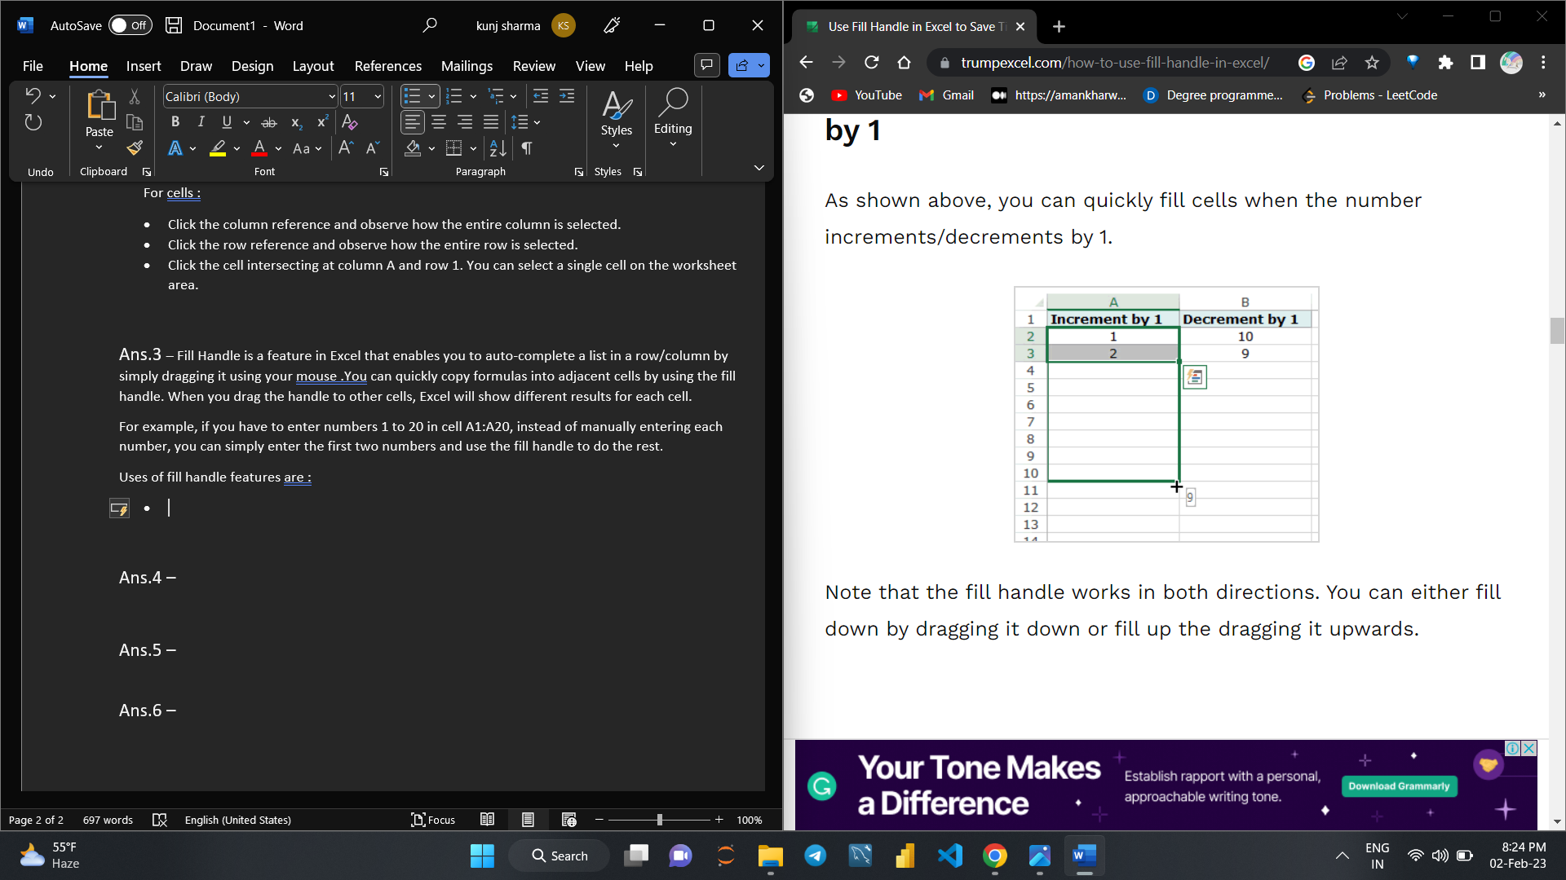

* You can use fill handle in Excel to autocomplete weekday names. It could either be the three alphabets nomenclature (Mon, Tue…) or the full name (Monday, Tuesday…).
* You can easily autofill dates using the fill handle in Excel. Any date format that is recognized by Excel can be used by the fill handle.

Ans.4 – Autofill Numbers that Increment/Decrement by 1 as shown below , the fill handle works in both directions. You can either fill down by dragging it down or fill up the dragging it upwards.



* You can use fill handle in Excel to autocomplete weekday names. It could either be the three alphabets nomenclature (Mon, Tue…) or the full name (Monday, Tuesday…).
* You can easily autofill dates using the fill handle in Excel. Any date format that is recognized by Excel can be used by the fill handle.

Ans.5 – Flash Fill automatically fills your data when it senses a pattern. For example, you can use Flash Fill to separate first and last names from a single column, or combine first and last names from two different columns. Note: Flash Fill is only available in Excel 2013 and later.

Speed up your workflow with Microsoft Excel’s Flash Fill feature. Learn how to use Flash Fill in Excel and become a pro with our guide.

Excel comes with a wide selection of features, each bringing something useful to the table. However, one of the most used and loved tools in Microsoft’s spreadsheeting app is Flash Fill. In this article, we’ll introduce what Flash Fill exactly is, and how to use it efficiently.

Flash Fill is a feature suitable for both beginners and experienced users. It’s helpful to utilize in all sorts of projects, as it allows you to streamline your workflow and take advantage of artificial intelligence.

Usually Flash Fill starts automatically, and you only need to provide a pattern. Here's how:

1. Insert a new column adjacent to the column with your source data.
2. In the first cell of a newly added column, type the desired value.
3. Start typing in the next cell, and if Excel senses a pattern, it will show a preview of data to be auto-filled in the below cells.
4. Press the Enter key to accept the preview.

Ans.6 – 